
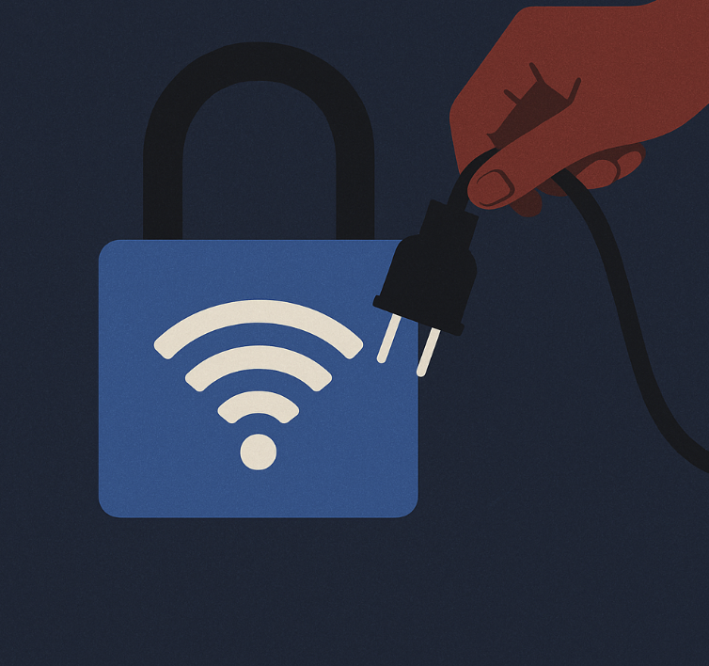
Human Rights Council (UNHRC)
Preventing Internet Blackouts as a Tool of Oppression and Censorship
Tanushka Roy

Forum: Human Rights Council
Issue: Preventing Internet Blackouts as a Tool of Oppression and Censorship
Name: Tanushka Roy
Position: Deputy Chair
Introduction:
In recent years, governments across the globe have increasingly resorted to internet shutdowns as means of control over the flow of information during periods of unrest, protests, or elections. These shutdowns are often used to stop people from speaking out, silencing the ones who disagree with government ideals, and restrict access to communications platforms. Access Now, a non-profit organisation defending digital rights globally, defines internet shutdowns as “an intentional disruption of internet or electronic communications, rendering them inaccessible or effectively unusable…to exert control over the flow of information.” Hence, it is described as means of oppression and censorship. According to Access Now’s ‘#Keep it On’ report, the number of internet shutdowns increased from 75 in 2016 to 213 in 2019. Unlike countries that use advanced tools to quietly filter or block content, many governments use more direct methods, such as internet blackouts or blocking social media platforms for a certain period. As the internet becomes more important for communication, information, and free expression, these blackouts raise serious concerns about human rights. This report looks at why blackouts occur, how they are carried out, and what effect they have on people’s rights, in hopes that the UN Human Rights Council remains involved in resolving this issue.
Definition of Key Terms:
Access Now
An international non-profit organisation (NGO) that defends digital rights globally. It is known for monitoring internet shutdowns, publishing reports, and hosting the annual ‘RightsCon’ summit on human rights in the digital age.
Censorship
The suppression of speech, public communication, or other information. This is done on the notion that the information suppressed is harmful, or sensitive. It can be conducted by governments, but also other private institutions.

Digital Rights
The rights individuals have, to access, use, create, and publish digital media or use electronic devices and networks. This includes rights to privacy, freedom of expression online, and access to information.
Internet Blackout/Shutdown
An intentional disruption of internet services by a government or authority, usually during protests, elections, or crises. It blocks people from accessing the internet either completely or partially in a specific area.
Mesh Network
A decentralised network where each device (node) connects directly to others nearby, rather than through a central point. This makes it more difficult for authorities to block internet access, as there is no single point to switch off.
Proxy server
A tool that acts as a gateway between users and the internet, allowing people to bypass restrictions or censorship by rerouting their internet traffic through another server.
Public Examination
A formal occasion in which government ministers/officers are asked questions regarding their actions or plans by officials.
Telecom Operator
A company that provides communication services, including internet access. These companies are often pressured by governments to comply with shutdown orders and can be key in enabling or resisting blackouts.
General Overview:
Origins and Evolution of Internet Blackouts
One early and prominent example of an internet blackout was the 2011 Arab Spring, during which, several regimes attempted to reduce social media and internet usage to suppress mass protests and uprisings. These early shutdowns revealed new ways of control. This included the ability to reduce digital freedoms to limit the flow of information.
By the late 2010s, this practice had become increasingly widespread. In 2019 alone, there were 35 cases of internet blackouts that lasted more than seven days, reported across a range of countries including Sri Lanka, Turkey, Zimbabwe, Iran, and Iraq. As a result, in all these cases, governments adopted this method during critical moments such as protests, elections, or public examinations.
A particularly significant case during this period was Chad, which experienced one of the first longest media blackouts in recorded history; a 472-day shutdown from March 2018 to July 2019. The blackout mainly targeted platforms such as WhatsApp and Facebook (now Meta) and other telecom operators. Chadian President Idriss Déby defended the decision by highlighting national security threats posed by terrorism. Upon lifting restrictions in July 2019, the President justified his beliefs, saying “For a country like Chad that has gone through dark times, it is not permissible for the internet to be hijacked for malicious purposes by certain individuals with evil intentions for peace and national unity.”
Such grounds have become a common theme among governments enforcing shutdowns. Authorities often frame these actions as protective measures as means to maintain national security, and prevent the spread of misinformation, or combat terrorism. However, critics argue that the real motive often lies in suppressing political opposition, hiding human rights abuses, or preventing the spread of negative information during politically sensitive events.
In parallel, global awareness and concerns regarding internet blackouts is on the rise. In 2016, the UN officially recognised the access to internet as a basic human right. This, therefore, frames blackouts as violations of digital freedoms and gave rise to organisations such as Access Now which document these shutdowns, emphasising their human impact.
Notable Cases
Several extended and high-profile shutdowns show the growing severity of this method. In India, the region of Jammu and Kasmir experienced a complete internet blackout beginning August 5, 2019. This region in India is subject to decades-long dispute with neighbouring countries, Pakistan and China, hence, its frequent internet blackouts. In 2019, this region experienced 552 consecutive days of internet blackout, one of the longest.
In Myanmar, the longest ongoing comprehensive shutdown continues, lasting over 240 days. These examples reflect the increasing use of internet disruptions and long and short-term methods of control.

Recent Trends and Global Developments
In 2023, the number of shutdowns reached an all-time high, with a significant shift in causes and geographic spread. For the first time, armed conflict overtook protests as the main cause for blackouts. Shutdowns were put into place during (or in waiting) of military actions in regions of constant tension such as Gaza, Ukraine, Myanmar, and Sudan. These disruptions were often couples with airstrikes or other forms of violence, while civilians were cut off from critical emergency information. However, these shutdowns were supposedly not national but put into place externally, thus, through rival nations.
Another alarming development is the increasing number of shutdowns which were linked with natural disasters. In Iraq and Myanmar, for instance, internet blackouts increased the effects of earthquakes and cyclones by preventing people from receiving warnings or accessing aid. In Turkey and Libya, authorities put shutdown into place following natural disasters to suppress public criticism of government responses.
Human Impacts and Rights Violations
The human toll of internet blackouts is substantial. Beyond preventing daily communication, these disruptions impact lifelines during emergencies, endanger lives by restricting access to healthcare and evacuation information. Shutdowns are often imposed without warning. According to Access Now, in 93% of cases in 2023, the public received no advance notice. This lack of transparency intensifies fear, instability, and mistrust during already sensitive situations.
Journalists, activists, and marginalised groups are especially affected as many governments allegedly target specific platforms to suppress minority communities. Shutdowns hinder the free flow of information often becoming a method of oppression in not only conflict zones, but also areas of peacetime governance.
Key Events Timeline
2011: Arab spring - Widespread internet blackouts in countries like Egypt, Iraq and Syria during mass uprising and protests
2016: UN recognition - The UN officially recognised access to internet as a basic human right
March 2018 – July 2019: Chad Social Media Blackout - Longest media blackout in history (at the time), targeting platforms such as WhatsApp and Facebook (now Meta).
August 5, 2019: India Blackout Jammu and Kashmir - Complete internet shutdown initiated during political restructuring of the region
2019: Global spike in shutdowns - 35 shutdowns lasting more than seven days reported globally
2020 - present: Myanmar blackout - Ongoing internet disruptions following a military coup
2023: Record high in Global shutdowns - Highest number of internet blackouts recorded. Governments imposed blackouts during natural disasters to prevent public criticism
Principal Stakeholders
Access Now
Digital rights NGO founded in 2009 in California, now based in Brooklyn. Advocated for an open and secure internet through tracking and publishing data on shutdowns. It also hosts the ‘RightsCon’ summit to promote digital freedom. It has initiated the ‘#Keep it On’ movement through which they publish reports and other findings.
India
A democratic nation and the world leader in internet shutdowns. Enforced 771 blackouts from 2016-2023, and over 50 in 2024 alone. While not officially anti-internet, the Indian government frequently imposes blackouts to manage protests, unrest, and public examinations. Critics argue the scale and frequency are disproportionate and undemocratic.
Meta / WhatsApp
Global tech company and messaging platform owned by Meta. Users in blackout-affected regions often lose access to WhatsApp due to restrictions on mobile data or social media platforms. They strongly oppose shutdowns. In response, WhatsApp introduced a proxy feature to help users connected during blackouts and publicly criticised disruptions that block urgent communication.
Myanmar
It is a military-ruled nation, with a history of authoritarian internet control. Put in place one of the longest shutdowns following the 2021 unrest, suppressing dissent.
United Nations (UN)
In 2016, the UN declared internet access as a fundamental human right. As a result, internet shutdowns can be seen as violations of these rights, particularly in terms of freedom of expressions, and access to information.
Ukraine
Nation in war with Russia since 2022. It is frequently targeted by Russian cyberattacks and Russian military enforced internet disruptions during wartime. Ukraine frames internet access as essential to civil defence and survival.
Potential Avenues for Resolution
Creating Internet Regulations and Frameworks: It is possible to create or strengthen existing international agreements by which internet shutdowns are prohibited. This can be done under very well defined, rules which are aligned, and approved with member states.
Technological Methods of Bypassing Shutdowns: It is further possible to encourage the development of decentralised internet services, that are harder to shut down centrally. Such examples can include Mesh Networks. This allows for maintaining critical communication paths or methods when centralised systems are censored.
Strengthening Reporting and Monitoring of Shutdowns: Member states can also work together to develop or improve international monitoring mechanisms and increase ways of public reporting to ensure the rightful use of internet blackouts.
Promoting Public Awareness Campaigns: The creation of global educational initiatives to build public awareness regarding the issue. It can help people understand their digital rights and teach them how to stay connected during a blackout and perhaps organise peaceful resistance against unfair shutdowns.
Suggested Resources
https://www.accessnow.org/wp-content/uploads/2020/02/KeepItOn-2019-report-1.pdf - #KeepitOn report 2019, has data related to how many internet blackouts took place as well as causes and further steps.
https://www.accessnow.org/wp-content/uploads/2024/05/2023-KIO-Report.pdf #KeepitOn report 2023, has data related to how many internet blackouts took place as well as causes and further steps.
https://www.pastemagazine.com/tech/the-un-declares-internet-access-a-basic-human-righ- The United Nations affirms that internet is a basic Human Right, 2016

References
Access Now. GROWING VIOLENCE Internet Shutdowns in 2023. 2023.
Antoniuk, Daryna . “Ukraine’s Largest Telecom Operator Shut down after Cyberattack.” Therecord.media, 12 Dec. 2023, therecord.media/kyivstar-cyberattack-telecom-shutdown-ukraine.
Bhattacharya, Ananya. “India Shuts down the Internet Far More than Any Other Country.” Rest of World, 27 Sept. 2024, restofworld.org/2024/india-internet-shutdown-record/.
Choudhury , Rizwan . “WhatsApp Will Now Enable Messaging during Internet Outages, Here’s How.” Mashable Middle East, 6 Jan. 2023, me.mashable.com/tech/23782/whatsapp-will-now-enable-messaging-during-internet-outages-heres-how#:~:text=internet%20is%20down.-,When%20governments%20shut%20down%20or%20ban%20access%20to%20the%20internet,internet%20outages%20around%20the%20world.
Christopher, James. “Internet Blackout: A Guide When Screens Go Dark - James Christopher - Medium.” Medium, 16 Feb. 2025, jameschris.medium.com/internet-blackout-a-guide-when-screens-go-dark-f836903978b4. Accessed 29 Apr. 2025.
Coppi, Laura Winninger, Giulio. “Internet Shutdowns and Atrocities in Ukraine.” Access Now, 23 Feb. 2024, www.accessnow.org/internet-shutdowns-and-atrocities-in-ukraine/.
Freedom Online Coalition . “Joint Statement on Internet Shutdowns and Elections.” Freedom Online Coalition , Oct. 2023, freedomonlinecoalition.com/joint-statement-internet-shutdowns-and-elections/.
Haridy, Rich . “How Governments Shut the Internet down to Suppress Dissent.” New Atlas, 27 Feb. 2020, newatlas.com/telecommunications/internet-shutdown-global-report-access-now/.
House, Macopedia Software. “Dictionary.” Macmillanenglish.com, 2025, www.macmillanenglish.com/nl/dictionary. Accessed 9 May 2025.
Madziwa, Prince Kudakwashe . Effects of Network Disruptions on Health Service Delivery among Private Practicing Physicians in Bulawayo Metropolitan Province, Zimbabwe. 2023, internews.org/wp-content/uploads/2022/08/Network-Shutdowns-and-the-Health-Delivery-System-in-Zimbabwe.pdf.
McKenney , Kyle . “The UN Declares Internet Access a Basic Human Right.” Paste Magazine, 26 July 2022, www.pastemagazine.com/tech/the-un-declares-internet-access-a-basic-human-righ. Accessed 29 Apr. 2025.
Root, Rebecca L. “In Myanmar, Internet Shutdowns Hinder Earthquake Aid Response.” Reuters, 9 Apr. 2025, www.reuters.com/world/asia-pacific/myanmar-internet-shutdowns-hinder-earthquake-aid-response-2025-04-09/.
Tackett, Zach Rosson, Felicia Anthonio, Carolyn. “Internet Shutdowns in 2023: The #KeepItOn Report.” Access Now, 15 May 2024, www.accessnow.org/internet-shutdowns-2023/.
United Nations. “Universal Declaration of Human Rights.” United Nations, 1948, www.un.org/en/about-us/universal-declaration-of-human-rights.

